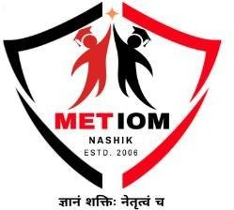

A MINI PROJECT REPORT ON
“TraceLock: Secure File Management and Task Tracking System”

UNDER THE FACULTY OF MANAGEMENT

Submitted by
Punam Sunil Nikam,MCA-40 Nikhil Govinda Patil,MCA-47 Shubham Santosh Gangurde MCA-19

Prof.Sonia Borse

Assistant Professor

Department of MCA
MET’s Institute of Management

MCA Sem-II
Academic Year 2025- 2026

DECLARATION

We here by declare that the project work titled TraceLock: Secure File Management and Task Tracking System submitted to MET’s Institute of Management, Nashik is a record of an original work done by us under the guidance of Prof. Sonia Borse, Department of MCA, MET’s Institute of Management, Bhujbal Knowledge City, Adgaon, Nashik in the A.Y. 2025-26 for a partial fulfillment of requirement for the Completion of Mini Project.This report has not been submitted to any other University or Institute for the award of any degree or diploma

Student Name:
MCA-40, Punam Sunil Nikam MCA-47, Nikhil Govinda Patil MCA-19, Shubham Santosh Gangurde

Date: Place:

ACKNOWLEDGEMENT

We would like to express our special thanks of gratitude’s to our Project guide

Prof.Sonia Borse Assistant Professor, MET’s Institute of Management, Bhujbal Knowledge City, Adgaon, Nashik for his/her able guidance and support in completing this report.
We would like to extend my gratitude to Dr. Yogesh Gaikwad, In-Charge Director, MET’s Institute of Management, for providing us with all the facility that was required to complete this report successfully.
We also thankful to the Management of Bhujbal Knowledge City, Nashik for providing us infrastructure and lab facility to completion of this Project.
At last but not the least we are thankful to all faculty members, staff, and friends who have been always helping and encouraging us throughout the period of this project.

Name of Student’s:

MCA-40, Punam Sunil Nikam MCA-47, Nikhil Govinda Patil MCA-19, Shubham Santosh Gangurde

Abstract

TraceLock is a comprehensive web-based file management and task tracking system designed to streamline document sharing, access control, and task assignment within organizational environments. The application implements a hierarchical role-based access control system with two primary user roles: Administrators and Employees. This system ensures secure file distribution, collaborative work management, and efficient task allocation across different departments or teams. TraceLock addresses the need for a centralized platform where sensitive files can be shared with specific employee groups while maintaining complete audit trails and access controls. The platform provides a user-friendly interface for both administrative management and employee collaboration.

The project is built on a modern full-stack web architecture utilizing Node.js and Express.js for the backend server, with React.js as the frontend framework for a responsive user interface. The system employs MySQL as the relational database management system to store user credentials, file metadata, task assignments, and group information. For file handling, the application integrates Multer for efficient file uploads and storage management, while PDF-Lib and DOCX libraries enable document manipulation and generation capabilities. The backend is structured following the Model-View-Controller (MVC) architecture pattern, ensuring clean code organization with separate routes, controllers, and middleware layers. Cross-Origin Resource Sharing (CORS) is configured to manage secure communication between frontend and backend. This architecture promotes maintainability, scalability, and separation of concerns across all layers.

TraceLock implements enterprise-grade security mechanisms using JSON Web Tokens (JWT) for stateless authentication, combined with bcrypt password hashing to securely store user credentials. For password recovery, the application implements a two-step verification process using OTP (One-Time Password) sent via email through Nodemailer integration. Role-based access control middleware verifies user identity and authorization level before granting access to protected resources, preventing unauthorized data access. JWT verification middleware ensures only authenticated requests can access protected API endpoints, maintaining the highest security standards throughout the application.

TABLE OF CONTENT

Chapter | Chapter Name |  | Page No
1 | Introduction
1.1 | Introduction |  | 8
1.2 | Company/Organization Introduction |  | 9
1.3 | Existing Systems |  | 10
1.4 | Objective |  | 12
1.5 | Scope Of Work |  | 13
1.6 | Operating Environment |  | 15
 | 1.6.1 Software Specification |  | 15
 | 1.6.2 Hardware Specification |  | 16
1.7 | Description Of Technology used |  | 18
2 | Literature Review 20
3 | Proposed System/ Methodology
3.1 | User Requirement Specification |  | 21
3.2 | Design Specifications |  | 23
3.3 | Sequence Diagram |  | 25
3.4 | Component Diagram |  | 26
3.5 | Deployment Diagram |  | 27
4 | Result and Implementation
4.1 | Methods/Techniques | 28
4.2 | Implementation Details | 30
4.3 | Entity-Relationship Diagram | 32
4.4 | UML Diagram | 33
4.5 | Module Specification Diagram | 34
4.6 | Data Flow Diagram | 35
4.7 | User Interface Diagram | 36
4.8 | Use Case Diagrams | 37

4.9 | Testing Strategies | 38
4.10 | Output/Screenshots | 40
5 | Conclusion
5.1 | Conclusion | 45
5.2 | Limitations | 46
5.3 | Future Enhancements | 47
6 | Bibliography | 48
6.1 | Bibliography / References

Chapter 1: Introduction

Introduction

In modern organizations, Managing and sharing important files within an organization is often more complicated than it should be. Many companies still use emails or external storage platforms to exchange documents, which can create security risks and make tracking file access difficult. Employees also spend a lot of time searching for the right files, which affects productivity. In addition, there is often no proper system to assign tasks or monitor their progress across different teams. To address these issues, TraceLock was developed as a secure and centralized platform for file sharing and task management.

TraceLock is a web-based application designed to simplify how organizations handle files and tasks. The main objective of this project is to provide an easy-to-use system where administrators can upload files, create groups, and share documents with specific users in a controlled way. At the same time, employees can access shared files, download them, and manage their assigned tasks from a single dashboard. The project also demonstrates the use of modern technologies such as React, Node.js, and MySQL in building a complete application. Security features like password encryption and token-based authentication are included to ensure that only authorized users can access sensitive data. The system also maintains logs of file access and downloads to improve transparency.

TraceLock can be applied in various environments such as corporate offices, educational institutions, and government organizations where secure document handling and task management are essential. This project reflects practical knowledge of building secure login systems, working with databases, managing file uploads, and designing user-friendly interfaces. It provides a simple and effective solution to common challenges faced in real-world organizations.

Company/Organization Introduction:

TraceLock was developed as a professional software development project by a dedicated team of web developers committed to creating innovative solutions for real-world business problems. The team consists of experienced full-stack developers who specialize in designing scalable, secure web applications that address organizational challenges. With expertise in both frontend and backend technologies, the team ensured that TraceLock meets professional standards for enterprise-level applications. The project represents collaborative effort focused on understanding modern workplace requirements and industry standards for data security.

The mission of TraceLock is to revolutionize how organizations manage documents and assign tasks by providing a centralized, secure, and easy-to-use platform. We envision a workplace where file sharing is secure, task assignments are clear, and employee accountability is transparent through automated tracking. Our vision extends beyond creating software—we aim to demonstrate best practices in security, database design, and responsive user interface development.

TraceLock is built on three core values: Security, Simplicity, and Accountability that guide every design decision and feature implementation. The primary objective of this project is to showcase professional-grade web development skills while solving a genuine organizational problem affecting businesses worldwide. Through advanced encryption, intuitive interfaces, and detailed access logs, we demonstrate the ability to balance technical excellence with practical usability. This project serves as a complete software solution that addresses real workplace challenges while maintaining industry-standard security protocols. .

Existing Systems

In many organizations, file management is still handled using traditional methods such as email communication. Employees send and receive important documents through email attachments, which often leads to confusion due to multiple versions of the same file. Tracking who has accessed or modified a document becomes difficult, increasing the risk of data misuse. This approach also lacks proper organization and centralized control.
Another commonly used system is third-party cloud storage platforms like shared drives. While these platforms allow file sharing and storage, they often provide limited control over user access and permissions. Organizations may find it difficult to restrict files to specific groups or departments. Additionally, managing large volumes of data without a structured hierarchy can lead to inefficiencies and reduced productivity.

Standalone task management tools like Asana, Monday.com, and Trello focus primarily on task tracking but lack integrated file management capabilities for document distribution. Organizations using these tools must switch between multiple platforms to share files and manage tasks, creating workflow inefficiency and user frustration. The separation of file management from task assignment prevents companies from maintaining a unified record of task-related documents.

Some organizations use basic task management tools separately from file storage systems. These tools help in assigning and tracking tasks but are not integrated with document management. As a result, employees have to switch between multiple platforms to complete their work. This lack of integration increases complexity and reduces workflow efficiency across teams.

Overall, existing systems lack a unified solution that combines secure file management with task tracking. They often fail to provide strong security features, detailed access logs, and role-based access control. These limitations create challenges in maintaining data security, ensuring accountability.

Objectives

The primary objective of the TraceLock system is to develop a secure and centralized platform for managing files and tasks within an organization. The system aims to eliminate the challenges of scattered file storage and unstructured communication by providing a unified solution. It focuses on improving efficiency, security, and collaboration among users.

Another important objective is to implement a role-based access control mechanism that ensures only authorized users can access specific files and resources. Administrators should have full control over file uploads, group creation, and task assignment, while employees can securely access and manage their assigned work. This helps maintain data confidentiality and prevents unauthorized access.

The project also aims to simplify task management by integrating it with file sharing capabilities. Users should be able to assign tasks, track their progress, and access related documents from a single platform. This integration reduces dependency on multiple systems and enhances overall productivity.

Additionally, the system focuses on implementing strong security features such as password encryption, JWT-based authentication, and OTP verification for password recovery. These measures ensure that user data remains protected at all times. The project also maintains activity logs to provide transparency and accountability.

Finally, the objective of TraceLock is to demonstrate the practical implementation of modern web technologies like React.js, Node.js, and MySQL in building a scalable and user-friendly application. It aims to provide a real-world solution that can be effectively used across various organizational environments.

Scope of Work

The scope of this project includes the design and development of a web-based file management and task tracking system that enables secure document sharing, controlled access, and efficient task assignment within an organization

Website Planning and Requirement Gathering

- Objectives: To develop a secure web-based system that allows administrators to manage files, assign tasks, and control access while enabling employees to access shared resources efficiently.
- Target Audience: Corporate organizations, educational institutions, government offices, administrators, and employees who require a centralized system for file management and task tracking.
- Core Features: User registration and login, role-based access control, file upload and download, group-based file sharing, task assignment and tracking, activity logs, and secure authentication using JWT.
- Design Preferences: A clean and user-friendly interface, responsive design, easy navigation, minimal complexity, fast performance, and support for multiple file formats.

System Design

- Architectural Design: Client-server architecture using React.js as the frontend, Node.js with Express.js as the backend, and MySQL as the database, following the MVC pattern.
- Dataflow Design: Flow of data from user requests on the frontend to backend processing, including authentication, file handling, and task operations, with responses sent back to the user interface.
- Database Design: MySQL database for storing user details, roles, file metadata, group information, task assignments, and activity logs.

Core Feature Development

- Authentication and Security: Implementation of JWT-based authentication, bcrypt password encryption, and OTP-based password recovery using email services.

- File Management System: Development of secure file upload, storage, download, and group-based sharing using Multer for file handling.

- Task Management Module: Enabling administrators to assign tasks, track progress, and manage employee activities within the system.

- Access Control Mechanism: Implementation of role-based access control to restrict and manage user permissions effectively.

Operating Environment

The TraceLock system is designed to operate in a modern web-based environment that supports both development and deployment of full-stack applications. It requires standard hardware and software configurations to ensure smooth performance and accessibility.

Software Specifications

The TraceLock system is developed using modern software technologies that support secure, scalable, and efficient web application development.

Operating System

  - Operating System: Windows 10/11, Linux, or macOS for development and deployment.

  - Frontend Technologies: React.js, HTML5, CSS3, and JavaScript for building a responsive and interactive user interface

  - Backend Technologies: Node.js with Express.js framework for handling server-side logic and API development.

  - Database Management System: MySQL for storing user data, file details, task information, and system logs.

Development Tools

  - Visual Studio Code: Visual Studio Code (VS Code) or any modern IDE for coding and debugging.

  - MySQL Workbench: Used to create a MySQL database for the project and creating tables to store the records.

Frontend

  - React.js: Used to build a component based, responsive, and interactive frontend.
  - Axios: Used for sending HTTP requests from the frontend to the backend server.

Backend Technologies

  - Server Side Language: JavaScript (Node.js)

  - Framework Used: Express.js for building RESTful APIs that handle user requests, authentication, file operations, and task management, and communicate with the frontend

Database

  - Database name: MySQL for storing user registration details, login credentials, file metadata, group information, task assignments, and system activity logs

APIs/Libraries/Frameworks:

  - Multer: Used for handling file uploads and managing storage efficiently on the server.
  - JSON Web Token (JWT): Used for secure authentication and authorization of users.
  - bcrypt: Used for encrypting user passwords to ensure data security.
  - Nodemailer: Used for sending OTP emails for password recovery and verification.
  - PDF-Lib & DOCX: Used for document generation and manipulation.
  - CORS: Used to enable secure communication between frontend and backend.

Hardware Specifications

The TraceLock system requires standard hardware components to ensure smooth development, deployment, and execution of the application. The following are the minimum and recommended hardware specifications:

Processor

- Type: Intel Core i3 or higher (Intel Core i5 or above recommended for better performance)
- Minimum Speed: 2.0 GHz.
- Recommended: Quad core processor or higher for better CNN model performance.

RAM

- Minimum Required: 4GB.
- Recommended: 8GB or higher for efficient machine learning processing and smooth multitasking

Storage

- Type: At least 10 GB of free disk space for application files, database, and uploads

Minimum Space Required: 10GB.
- Recommended: SSD for faster data access, dataset loading, and model execution.

Network Requirements

- Stable internet connection required for accessing the web application, updating datasets, and external product links.

Description of Technology Used

TThe TraceLock system is developed using modern web technologies that ensure scalability, security, and efficient performance. The combination of frontend, backend, and database technologies provides a complete full-stack solution for file management and task tracking.

Frontend:

  - React.js is used to develop a responsive and interactive user interface.
  - Provides user-friendly dashboards for administrators and employees.
  - Enables file upload, download, and task management features.
  - Displays data such as files, tasks, and user activities clearly.

Backend:

  - Node.js acts as the server-side runtime environment for handling client requests.
  - Express.js is used to build REST APIs for file management, authentication, and task operations.
  - Manages communication between frontend, database, and file system.

Authentication & Security:

  - JSON Web Token (JWT) is used for secure user authentication and authorization.
  - bcrypt is used to encrypt user passwords before storing them in the database.
  - OTP-based verification using Nodemailer is implemented for password recovery.
  - Ensures that only authorized users can access protected resources.

- File Management System:

  - Multer is used for handling file uploads and storage on the server.
  - Supports uploading, downloading, and managing multiple file types.
  - Enables secure file sharing within specific groups or users.
  - Maintains file metadata and storage structure efficiently.

Task Management Module:

  - Allows administrators to assign tasks to employees.
  - Enables tracking and updating task status within the system.
  - Provides a centralized platform for managing work activities.
  - Improves team coordination and workflow efficiency.

Database :

  - MySQL is used to store user information and login credentials securely.
  - Maintains records of files, groups, and task assignments.
  - Stores activity logs such as file access and downloads
  - Supports efficient data retrieval and management.

Chapter 2: Literature Review

The development of file management and task tracking systems has been an important area of research in modern software engineering. Various studies highlight the need for secure and efficient systems to manage organizational data. Traditional file-sharing methods such as emails and standalone storage systems have been widely used, but they often lack proper access control, security, and tracking mechanisms. Researchers have emphasized the importance of centralized systems to overcome these limitations and improve productivity.

Several existing solutions focus on cloud-based storage systems that allow users to upload and share files. While these systems provide convenience and accessibility, they often lack fine-grained control over user permissions and do not fully integrate task management features. Studies suggest that combining file management with task tracking in a single platform can significantly enhance workflow efficiency and collaboration among team members.

Research in web application development shows that modern technologies like React.js, Node.js, and MySQL provide a strong foundation for building scalable and responsive systems. The use of RESTful APIs and MVC architecture has been widely recommended for maintaining clean code structure and improving system performance. These technologies enable developers to create applications that are both user-friendly and capable of handling large volumes of data.

Security has also been a major focus in recent studies, especially in systems dealing with sensitive organizational data. Techniques such as JSON Web Tokens (JWT) for authentication and bcrypt for password encryption are commonly used to ensure data protection. Additionally, implementing role-based access control helps restrict unauthorized access and improves accountability within the system.

Based on the analysis of existing research and technologies, TraceLock is designed to address the gaps in current systems by providing a secure, centralized, and integrated platform for file sharing .

Chapter 3: Proposed System/Methodology

User Requirement Specifications

The TraceLock system is designed to meet the requirements of different types of users within an organization. The system mainly focuses on two types of users: Administrators and Employees. Each user has specific functionalities and access permissions based on their role.

Functional Requirements

- The system shall allow users to register and log in securely using authentication.
- The system shall verify users using JWT-based authentication.
- The system shall provide OTP-based password recovery through email.
- The system shall allow users to log out securely from the application.
- The system shall allow administrators to create, update, and delete user accounts.
- The system shall assign and manage roles such as Admin and Employee.
- The system shall allow administrators to manage user permissions and access control.
- The system shall allow administrators to upload files to the system.
- The system shall allow users to download files shared with them.
- The system shall enable administrators to share files with specific users or groups.
- The system shall allow administrators to create and manage user groups.
- The system shall allow assigning users to specific groups for access control.
- The system shall restrict file access based on group permissions.
- The system shall allow administrators to assign tasks to employees
- The system shall allow employees to view assigned tasks.
- The system shall allow employees to update task status (pending, in progress, completed)
- The system shall allow administrators to monitor task progress and status.
- The system shall maintain file metadata and storage information.

Non-functional Requirements

- The system shall ensure high performance with fast response time for all user requests.
- The system shall be scalable to handle an increasing number of users, files, and tasks.
- The system shall ensure high availability so that users can access the platform without interruptions.
- The system shall provide strong security mechanisms including encryption and secure authentication.
- The system shall ensure data privacy and confidentiality of all user information.
- The system shall protect against unauthorized access and data breaches using role-based access control.
- The system shall be user-friendly with a simple and intuitive interface for both admin and employees.
- The system shall support easy navigation across all modules and features.
- The system shall be responsive and compatible with different screen sizes and devices.
.

Design Specifications

The design specifications describe the overall structure and working of the proposed TraceLock system. The system is designed using a client–server architecture where the frontend, backend, database, and security modules work together to provide secure file management and efficient task tracking. The design focuses on security, scalability, usability, and proper role-based access control within an organization.

System Architecture

  - The system follows a client–server architecture for communication between frontend and backend.React is used for frontend interaction.
  - React.js is used for building the frontend user interface..
  - Node.js with Express.js is used for backend processing and API development.
  - MySQL database is used to store users, files, tasks, groups, and logs.

User Interface Design

  - Simple, clean, and user-friendly interface for both Admin and Employee.
  - Separate dashboards for Administrator and Employee roles.
  - Easy navigation for file upload, download, and task management.
  - Displays files, tasks, and activity logs in a clear and structured format.

Database Design

  - Stores user registration and login information securely.
  - Manages file metadata such as file name, type, size, and access details.
  - Stores task details including assignment, status, and updates.
  - Maintains group information for role-based file sharing.

Machine Learning Model Design

  - Uses JWT (JSON Web Token) for secure authentication and session management.
  - Implements bcrypt encryption for secure password storage.
  - Uses OTP-based verification for password recovery via email.
  - Implements Role-Based Access Control (RBAC) for restricting unauthorized access.

Dataflow Design

  - User logs in through the frontend interface.
  - Request is sent to the backend server for authentication.
  - After verification, user is redirected to their respective dashboard.
  - Admin uploads files and assigns tasks through the system.
  - Employees access files and update task status.
  - All activities are recorded in the database for tracking and auditing.

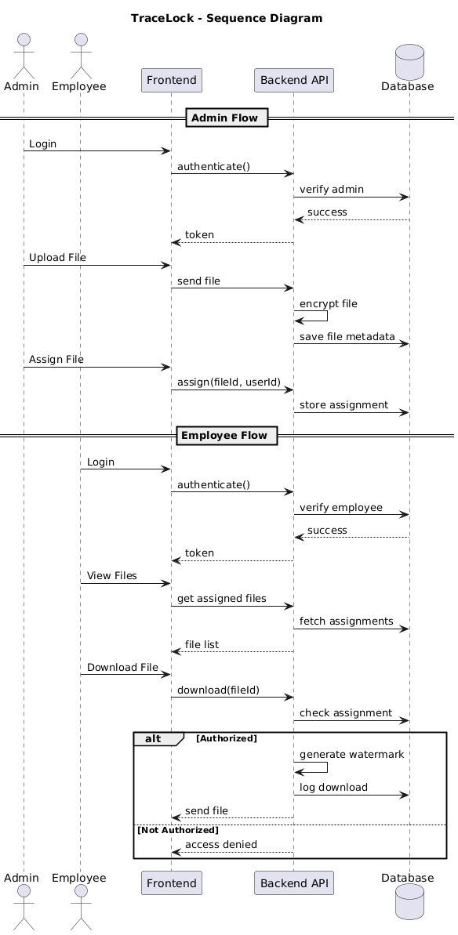
Sequence Diagram:

Fig 1: Sequence Diagram

Component Diagram

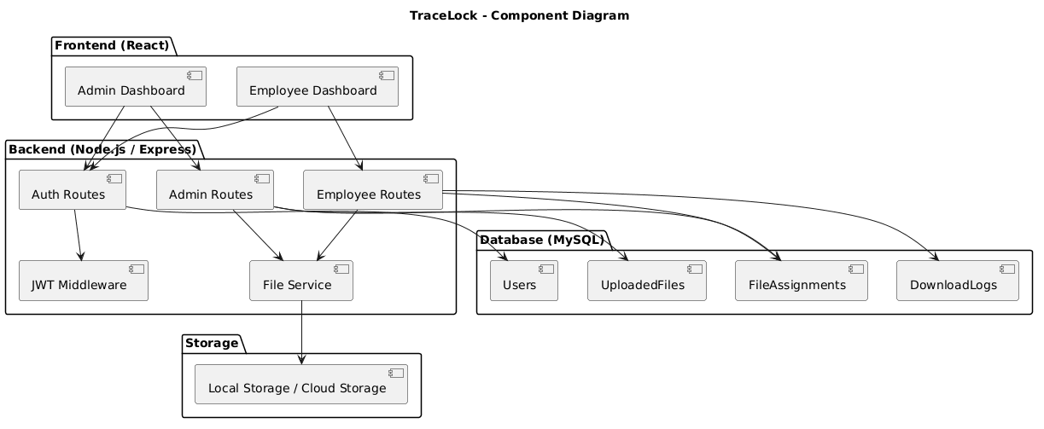

Fig 2: Component Diagram

Deployment Diagram

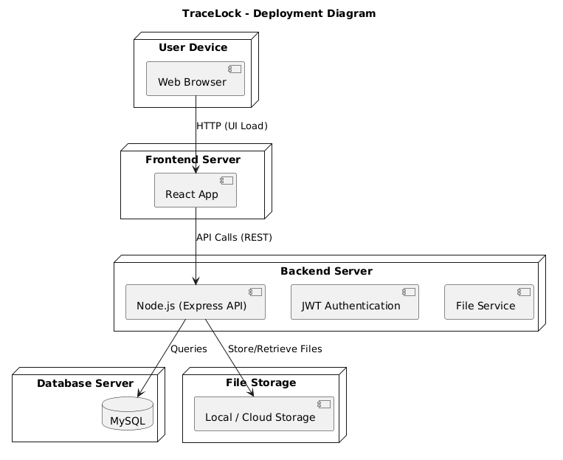

Fig 3: Deployment Diagram

Chapter 4: Result and Implementation

Methods/Techniques

The TraceLock system is implemented using modern web development methods and techniques to ensure secure, efficient, and scalable file management and task tracking. The system follows a structured approach where frontend, backend, database, and security mechanisms work together seamlessly.

- Client-Server Communication

- The system uses a client-server architecture for communication between frontend and backend.
- RESTful APIs are used to handle requests and responses efficiently.
- React.js frontend sends requests to Node.js backend for processing.
- JSON format is used for data exchange between client and server.

2. Authentication and Authorization Technique

- JWT (JSON Web Token) is used for secure user authentication.
- After login, a token is generated and used for accessing protected routes.
- Role-Based Access Control (RBAC) ensures different access levels for Admin and Employee.
- Unauthorized users are restricted from accessing sensitive data.

3.Database Management Technique

- MySQL relational database is used for structured data storage.
- Tables are designed for users, files, tasks, groups, and logs.
- Efficient queries are used for fast data retrieval and updates.
- Ensures data integrity and consistency across the system.

Implementation Details

The implementation of the TraceLock system is divided into multiple phases to ensure a structured development process. Each phase focuses on specific functionalities such as authentication, file management, task handling, and security integration.

Phase 1: User Authentication & Authorization:
- Login System: JWT-based authentication is implemented with secure password encryption using bcrypt.
- User Registration: New users can register and their details are securely stored in the database.
- Role-Based Access: Users are assigned roles such as Admin and Employee during login.
- Session Management: Token-based session handling ensures secure and stateless authentication.

Phase 2: File Upload & Management:
- File Upload Interface: Users can upload files through a simple and interactive UI.
- File Handling: Multer middleware is used to process and store uploaded files on the server.
- File Validation: File type and size validation are applied to ensure secure uploads.
- Metadata Storage: File details such as name, type, size, and owner are stored in the database.

Phase 3: Task Management Implementation
- Task Creation: Administrators can create and assign tasks to employees.
- Task Assignment: Tasks are linked with specific users or groups.
- Task Status Tracking: Employees can update task status (Pending, In Progress, Completed).
- Task Monitoring: Administrators can track overall task progress through dashboards.
4.2.1 : WorkFlow Diagram

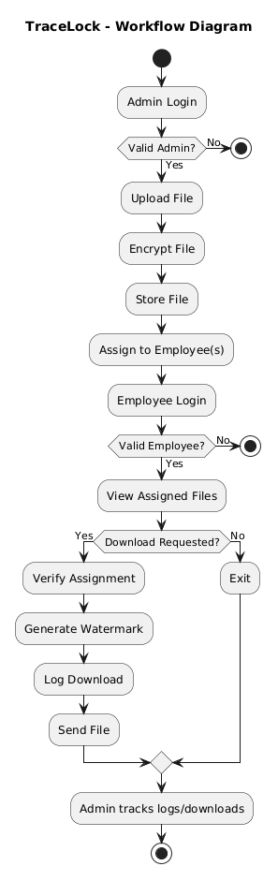
Fig 4: WorkFlow Diagram

Entity-Relationship Diagram

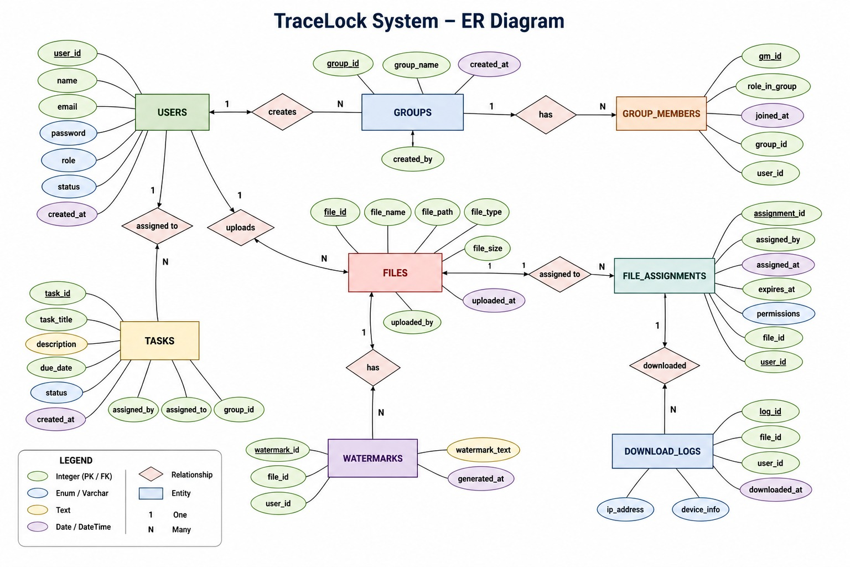

UML Diagram

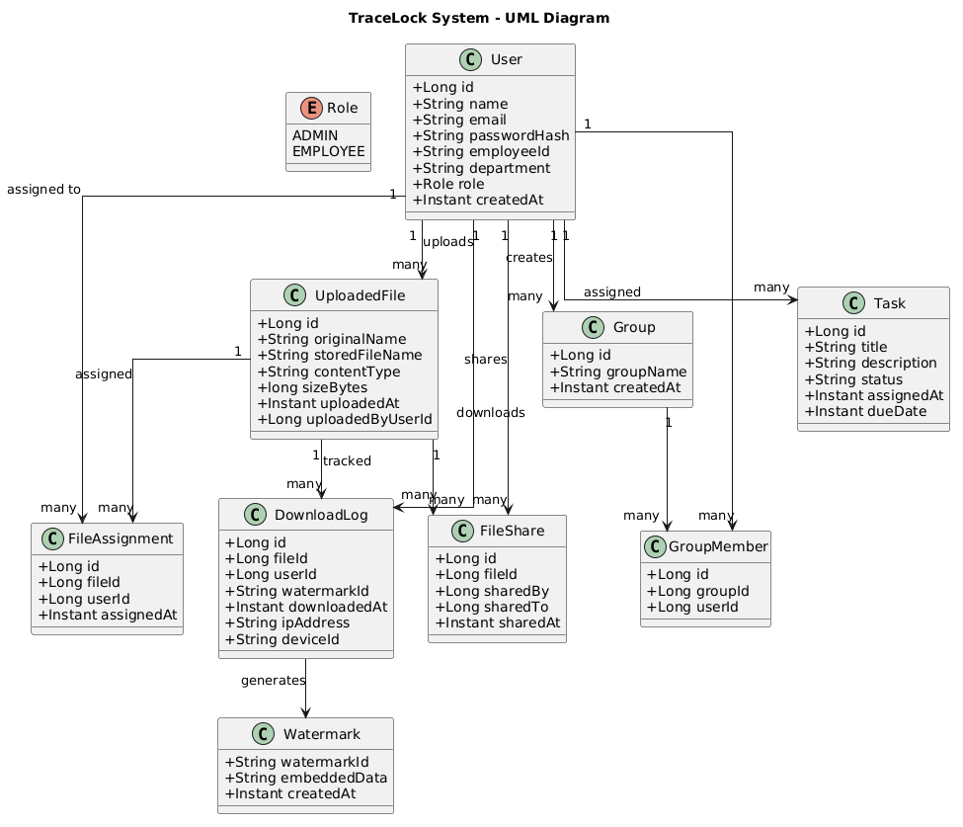

Module Specification Diagram

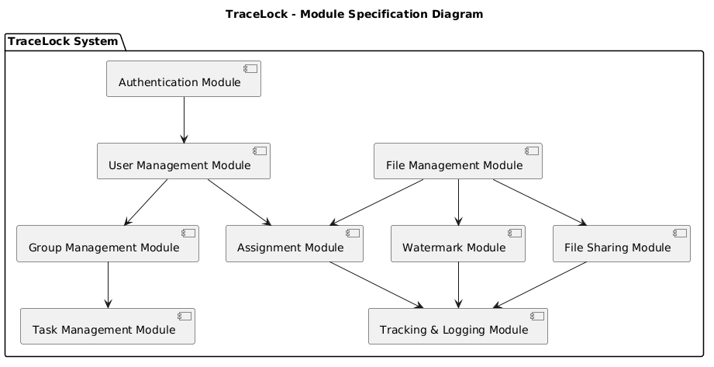

Data Flow Diagram

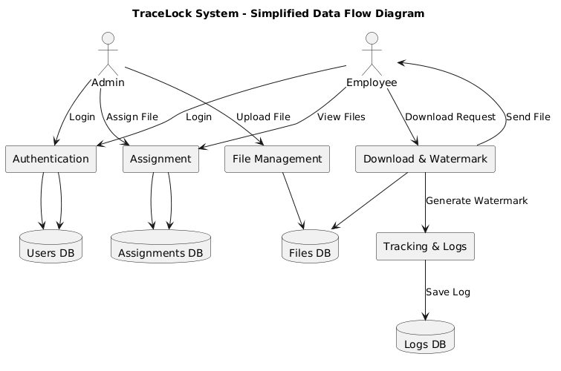
Fig 8: Dataflow Diagram

User Interface Diagram

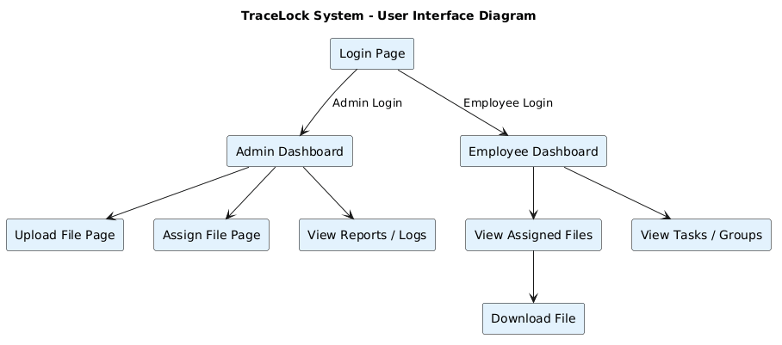

Fig 9: User Interface Diagram

Use Case Diagram

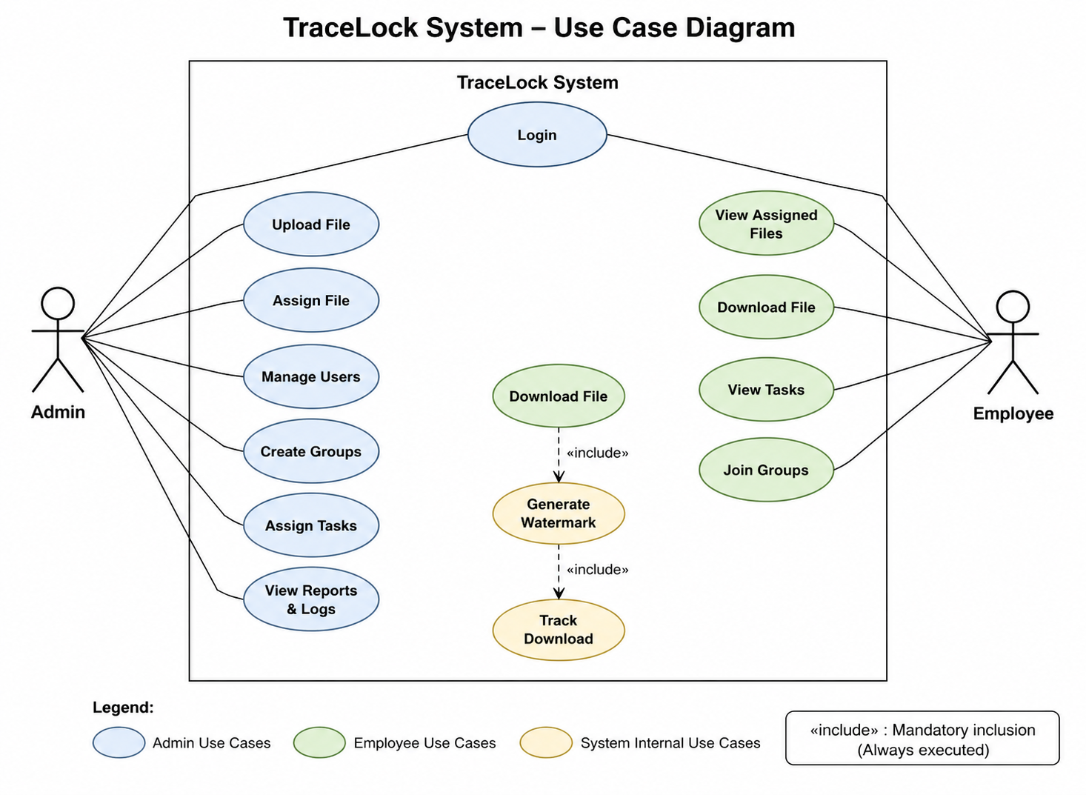
Fig 10: User Case Diagram

Testing Strategies

The TraceLock system is tested using different testing strategies to ensure that all functionalities work correctly, securely, and efficiently. Testing is performed at various levels to identify and fix errors before deployment, ensuring a reliable and stable application.

Unit Testing

- Individual modules such as login, file upload, and task management are tested separately.

- Each function is verified to ensure it performs its intended operation correctly.

- Helps in identifying bugs at the early development stage.

- Integration Testing

- Tests the interaction between frontend, backend, and database.

- Ensures smooth communication between React.js frontend and Node.js backend APIs.

- Verifies that data is correctly stored and retrieved from MySQL database.

- Checks proper working of file uploads, authentication, and task operations together.

- System Testing

- The complete TraceLock system is tested as a whole application.
- Validates overall system functionality, performance, and security.
- Ensures that all modules (authentication, file management, task management) work together properly.
- Confirms that system meets all functional and non-functional requirements.
.
- Performance Testing

- Evaluates system response time during file upload and retrieval.
- Checks how the system performs under multiple user requests.
- Ensures smooth operation even with large files and datasets.
- Identifies performance bottlenecks and improves efficiency.

Screenshots
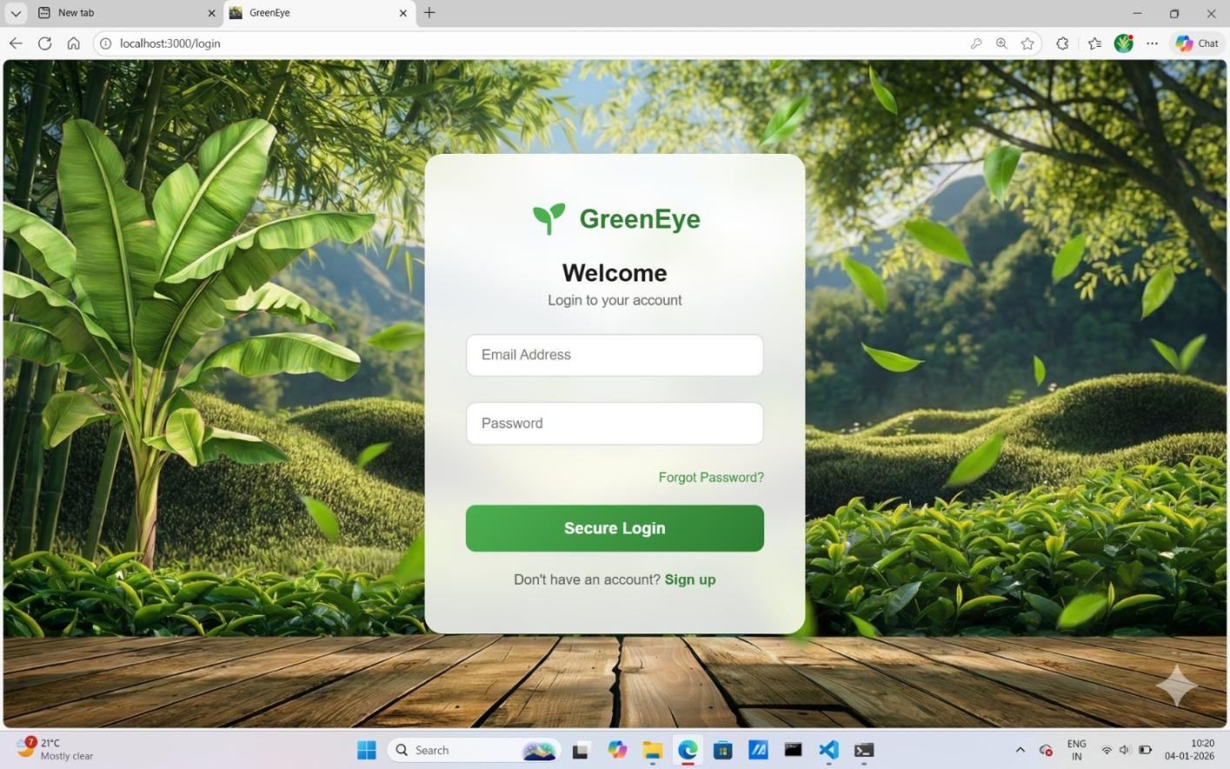


Fig 11: Login page
Fig 12: Main Page

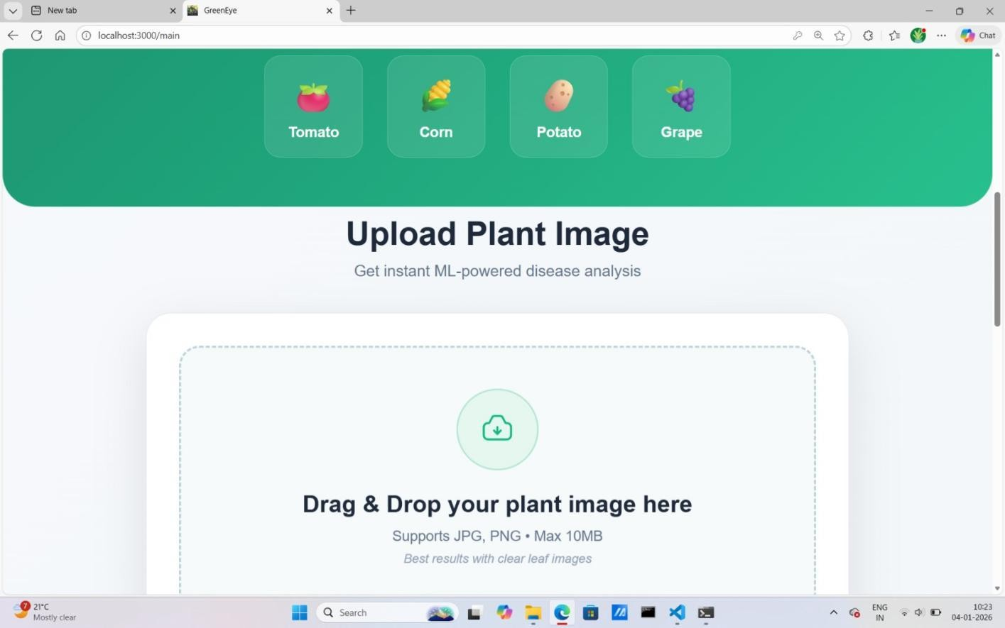
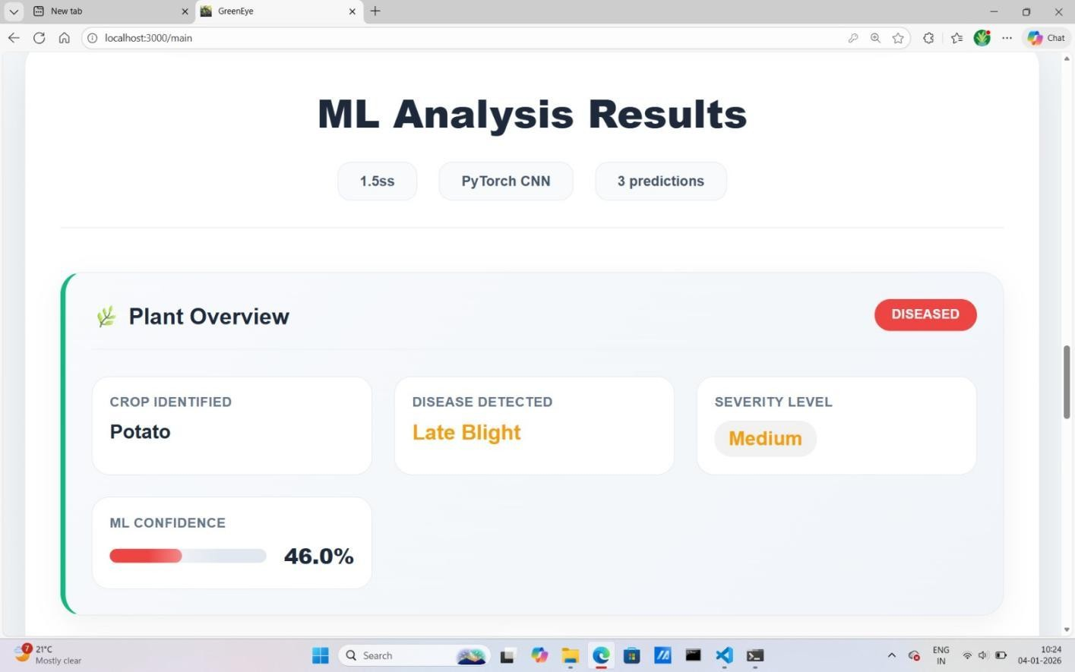

Fig 13: To upload the picture of your crop

Fig 14: 1st result page showing identification of crop and detected diseases

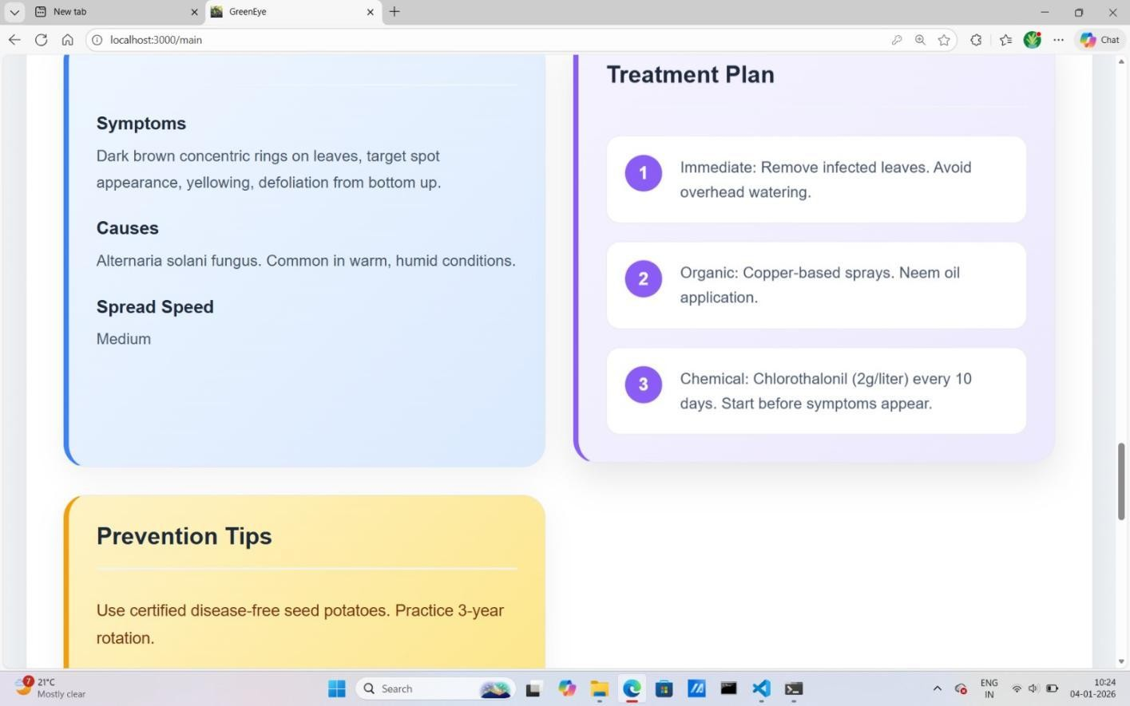
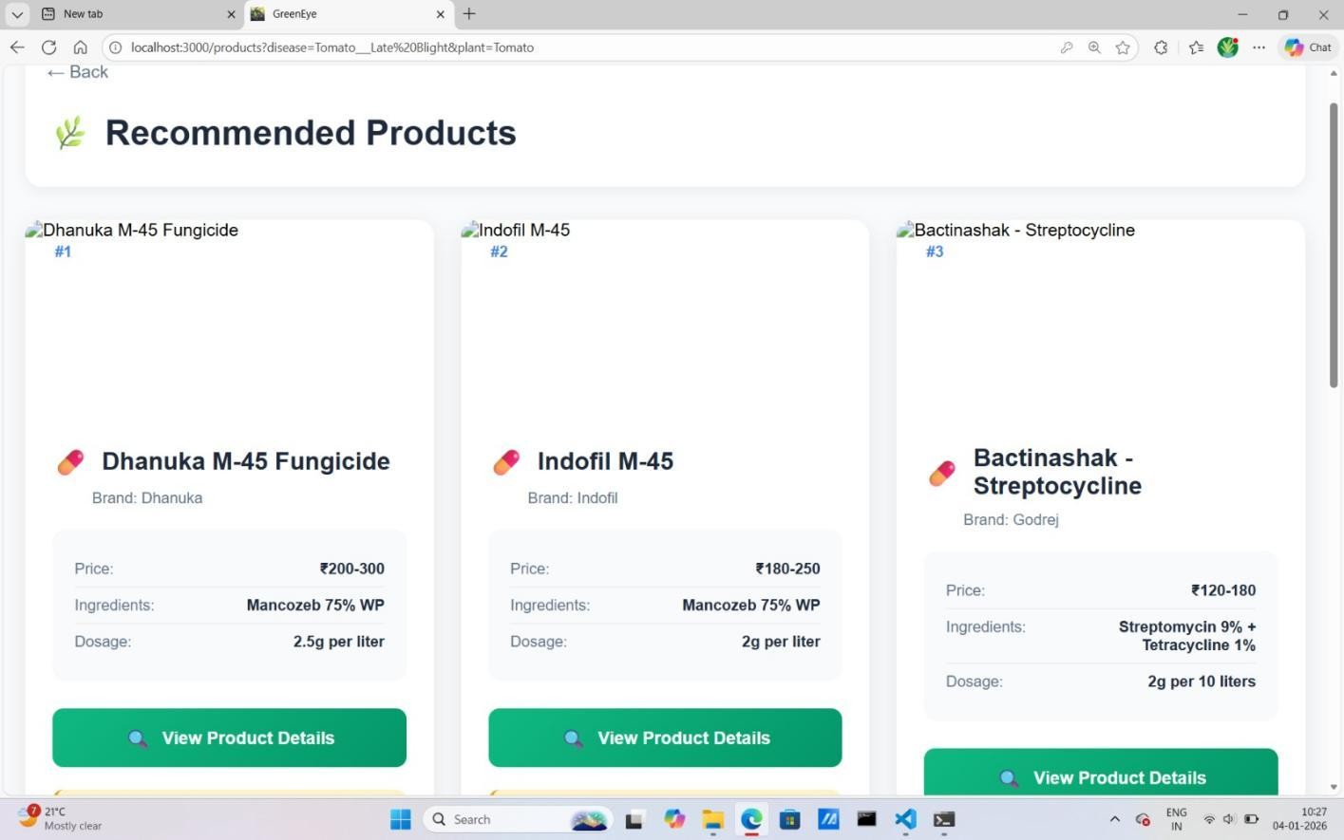

Fig 15: 2nd result page showing symptoms, treatment plan and prevention tips for identified diseases

Fig 16: Recommended products page for the identified crops

Tables
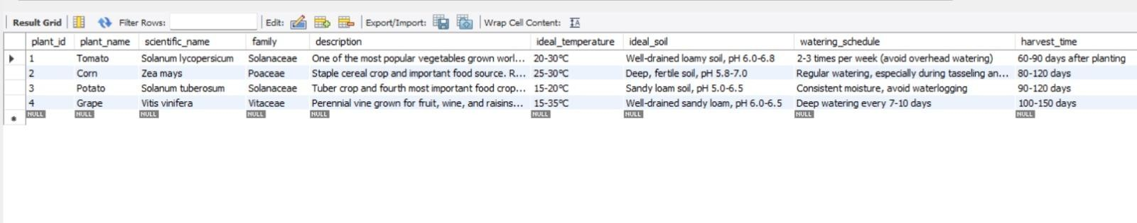
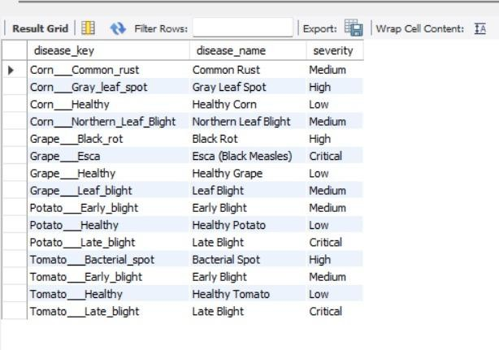
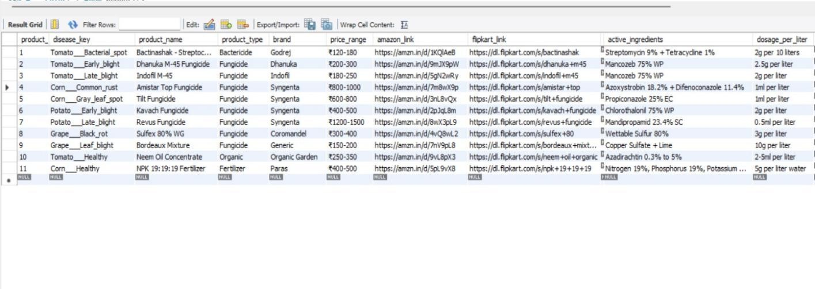
Table 1: Plants Table
Table 2: Diseases Table
Table 3: Products Table

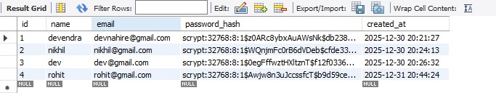
Table 4: Login Table

Chapter 5: Conclusion

Conclusion

The TraceLock system is successfully designed and developed as a secure and centralized platform for file management and task tracking within an organization. It effectively solves the problems of traditional file sharing methods by providing better control, security, and accessibility. The system integrates modern web technologies to ensure smooth and efficient operations.

The implementation of features such as role-based access control, JWT authentication, file sharing, and task management improves overall productivity and collaboration. It ensures that only authorized users can access sensitive data while maintaining transparency through activity logs. The system provides a user-friendly interface that makes it easy for both administrators and employees to use.

Overall, TraceLock demonstrates a practical application of full-stack web development using React.js, Node.js, and MySQL. It successfully combines security, scalability, and usability in a single platform. This project can be further enhanced in the future with additional features like real-time communication and advanced analytics.

Limitations

- Web Dependency: The system requires an active internet connection to access and use the application.

- No Offline Mode: TraceLock cannot function without server connectivity or backend access.

- File Size Limitations: Large files may face restrictions during upload due to server constraints.

- Browser Dependency: The system performance may vary across different web browsers.

- No Mobile Application: The system is currently limited to web platforms and does not support a dedicated mobile app.

- Scalability Constraints (Initial Stage): Performance may be affected if a very large number of users access the system simultaneously without optimization.

- Limited Real-Time Features: The system does not include real-time chat or live collaboration features.

Future Scope

- Advanced File Management: Integration of AI-based smart file search and automatic categorization of documents.

- Mobile Application: Development of Android and iOS applications for easy access and file management on mobile devices.

- Real-Time Collaboration: Addition of real-time chat and collaboration features for team communication.

- Cloud Integration: Integration with cloud storage services for scalable and secure file storage.

- Advanced Analytics: Implementation of dashboards with analytics for task progress, file usage, and user activity.

- AI-Based Enhancements: Use of AI for automatic task suggestions and intelligent workflow optimization.

- Third-Party Integration: Integration with external tools such as email services, calendar, and enterprise systems for better productivity.

References

[1] Kumar, R. (2023). Secure file management systems in modern web applications. International Journal of Software Engineering, 10(2), 34–46.

[2] Sharma, P., & Mehta, A. (2022). Role-based access control in enterprise applications. Journal of Computer Security Systems, 8(1), 15–28.

[3] Verma, S. (2021). JWT authentication and security mechanisms in web development. International Journal of Web Technologies, 7(3), 55–67.

[4] Gupta, N. (2022). Efficient task management systems using full-stack technologies. Journal of Software Development Studies, 9(4), 88–100.

[5] Patel, R., & Joshi, M. (2023). File handling and storage optimization in cloud-based systems. International Journal of Data Engineering, 6(2), 41–53.

[6] Singh, A., & Roy, K. (2024). Secure communication between client and server using REST APIs. Journal of Network Computing, 11(1), 22–36.

[7] Ministry of Electronics & IT, Government of India. (2024). Guidelines for secure web application development.

